Laptop Migration WITH
Paragon Drive Copy 11 Professional

Introduction
This document illustrates how to migrate your notebook software applications and data to a new drive using Paragon Drive Copy 11 Professional.
Most notebooks and laptops have only one connection port for a hard disk drive making migrations a challenge as they lack an additional port for this operation. This document illustrates a solution using Paragon Drive Copy 11 Professional.

System Requirements
Before installation, please make sure your computer meets the following minimum system requirements:
- Windows XP operating system, 32 or 64 bit edition
- Intel Pentium CPU or its equivalent, with 1GHz processor clock speed
- 512 GB of RAM
- Hard disk drive with 100 MB of available space
- SVGA video adapter and monitor
- Mouse, Keyboard
- Network Adapter
- CD/DVD Drive

Operation steps

Migration to a container FOR YOUR SYSTEM IMAGE
One of the possible scenarios of system migration on notebooks is the use of an external shared drive as temporary storage for a system image. You can copy your system and data to this container drive, swap drive in the computer and recover all of your information.
- Launch Paragon Drive Copy 11 Professional
- Click the Migrate Hard Disk to container menu option in the Migration menu.
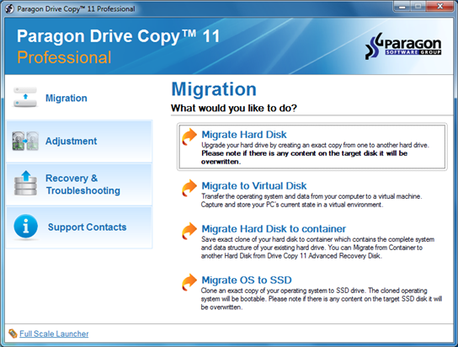
- The Migrate to Container wizard welcome screen will open. Click Next.
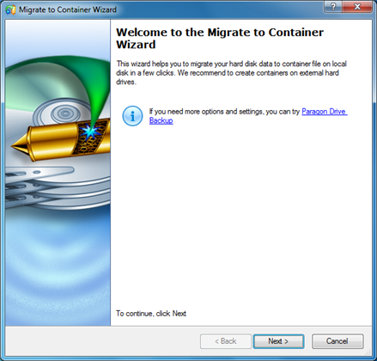
- Select your actual system disk for migration.
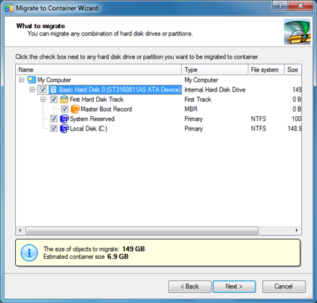
- Map the network shared drive where the container will be placed.
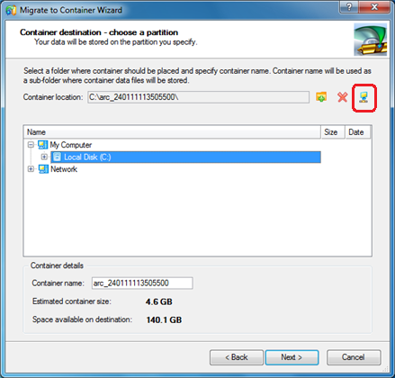
- Enter the shared drive network address.
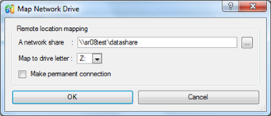
- Enter the login and password for the share if needed.
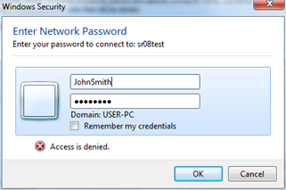
- Enter the container name and click next.
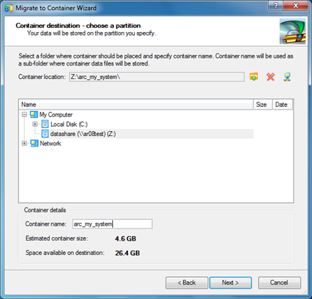
- The system will be copied.
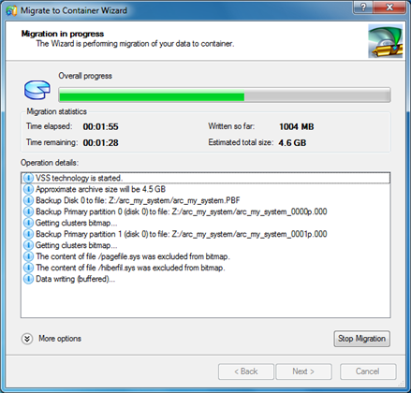
- Finish the wizard. Now you have your system stored in a remote container.
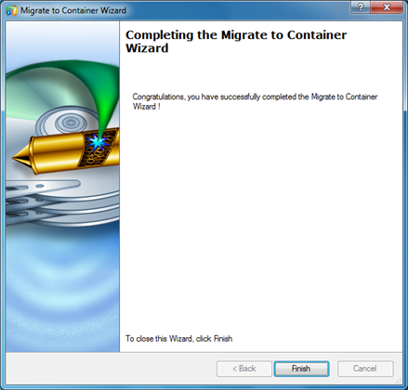
- You can replace the original HDD with a new one in the notebook and boot the computer using the WinPE Recovery CD.

Getting access to the container from The Recovery Media
To copy the data from the container to a new hard disk drive, boot your notebook with Paragon Drive Copy 11 WinPE Recovery Media. Then set the network up and mount the network share with the container.
- Load Paragon Drive Copy 11 Professional WinPE Media.
- Click the Configure Network menu option in the Tools menu.
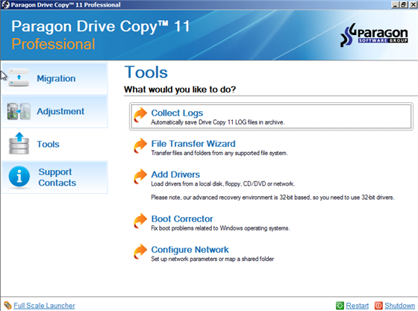
- Check that your network settings are correct and click the Network drives tab in the window.
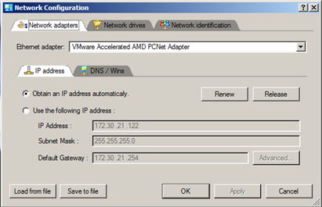
- Click the Map Network Drive button.
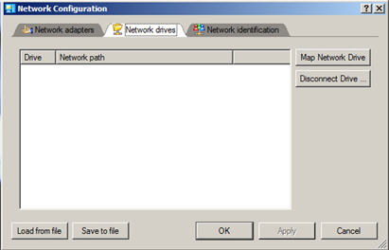
- Enter the path to the network share and access credentials.
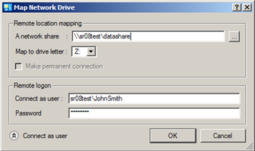
- Now the network share with the container is mounted and accessible.
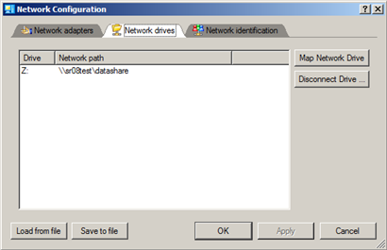

System recovery from the container
- Click the Migrate Hard Disk from Container menu option in the Migration menu.
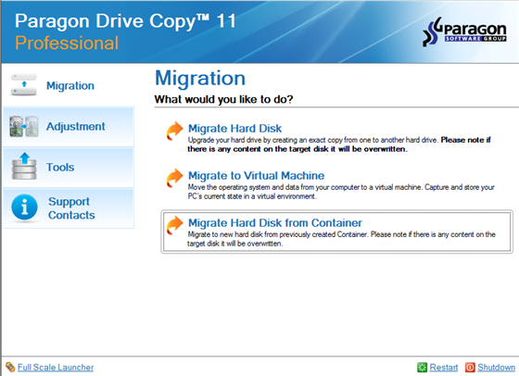
- The Migrate from Container wizard welcome screen will open. Click Next.
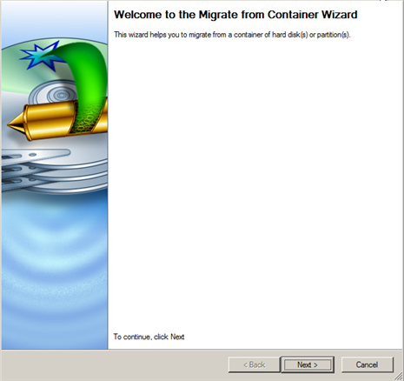
- Select the container.
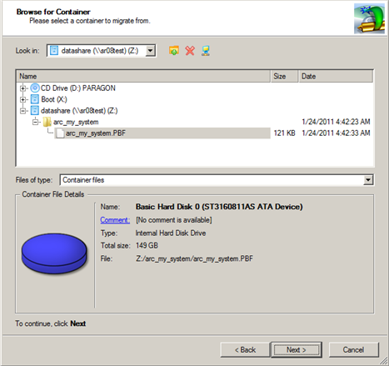
- Select the hard disk drive item to migrate.
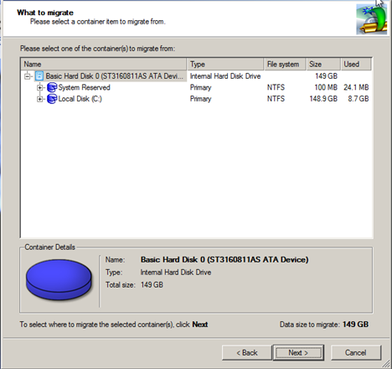
- Select the new hard disk drive as a migration target.
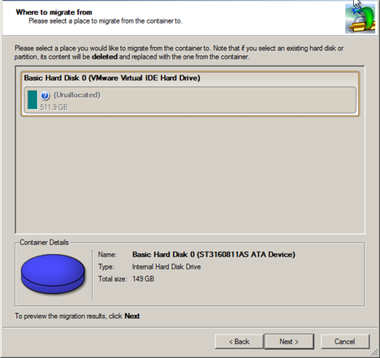
- Preview the migration results, if you agree, click Next. You can choose to resize the volumes for better free space usage.
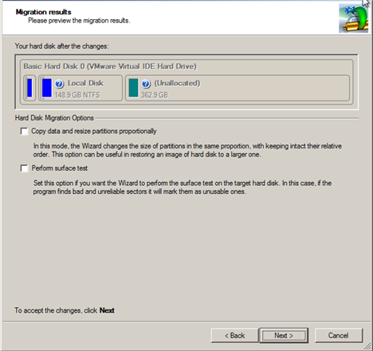
- Apply the changes physically.
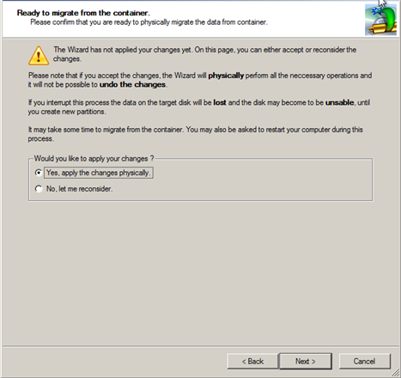
- Close the wizard.
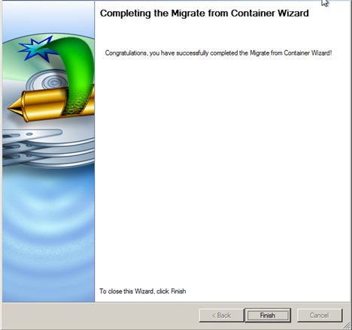
- Now you have migrated your system and data. You can reboot the computer and start the operating system.

More OPTIONS for System Migration on notebooks with Paragon Drive Copy 11
There are several other scenarios for system migration on notebooks with Paragon Drive Copy 11. You can use an external USB hard disk drive as a temporary storage for the container instead of using of the network share. After you create the container, swap the HDD in the notebook and perform the recovery operation with Drive Copy 11 WinPE Recovery Media.
You can also use an external USB adapter to connect a new HDD. Paragon Drive Copy 11 copies information from the old HDD to the new one, then you only need to exchange the drive.

